BWS Labour Sign-off (SysproCompanyA Access)
Version 2
Prepared: Tuesday February 22nd 2022

- The following tool is designed to review and edit employee labour as recorded from ShopClock Transactions.
- You may Create and edit a shift, assign an employee to a shift, and override an employee’s recorded hours.
- This is an additive to ShopClock. Employees, shifts and transactions need to be regularly maintained for this program to produce the best results.
- These forms are all found within SysproCompanyA access database (SysproCompanyS for Stargate employees). For help accessing the database, please contact IT.
- IMPORTANT: Since this project was implemented after Jan 26th 2022, ALL values before this date will be inaccurate. Values before then will likely show as 0 or nothing.
New to version 2:
- Choose which days of the week the lunch break is applied to (Shift Configuration).
- Select different values for thresholds for early and late transactions (Shift Configuration).
- Added Times of Day to the override form for clarity (Daily Labour Sign-off)

SysproCompanyA Main Menu now has 3 additional buttons in the ShopClock section:
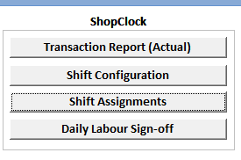

Shift Configuration:
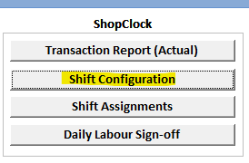
Opens this blank form:
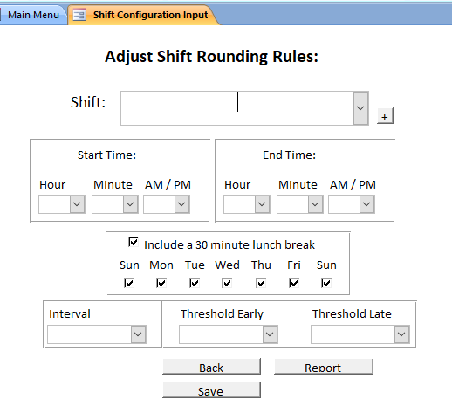
After selecting a shift from the drop down the remaining textfields will be populated:
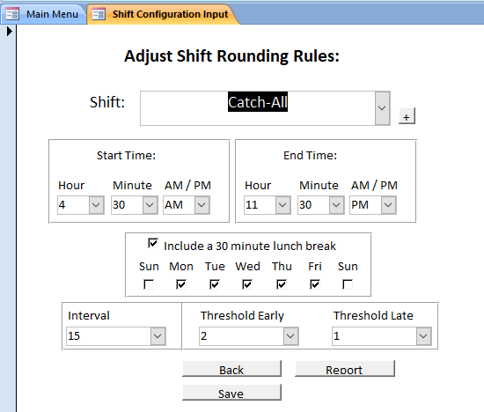
You can change the Shift’s start and end times using the dropdown selectors.
Decide if a 30 minute lunch will be included. This calculation will ALWAYS run even if the employee does not take their lunch.
Choose the rounding interval which will round the FIRST clock-in of the shift and the LAST clock-out of the shift for each employee. An Employee’s Transactions between their first sign-in and last sign-out will not be rounded.
Choose a rounding threshold which will allow an employee to sign in X minutes late OR early and still have their time rounded correctly. If threshold = 2, then for an 8AM start time all first-time sign-ins between 7:58 and 8:02 are rounded to 8AM.
Notes:
- The threshold and interval rounding values are used for both sign-in and sign-out rounding.
- The corresponding ShopClock shifts should have an automatic log-out somewhere during the shift to avoid non-sign-outs (Transactions without both a clock-in and clock-out will be ignored.)
- A corresponding ShopClock Shift must also have a wide-enough window that an employee can regularly sign-in and out within the set start and end times created in the above form. ShopClock will restrict any values if the window is too small.
To create a new shift click the ‘+’ button located beside the shift drop-down selector:
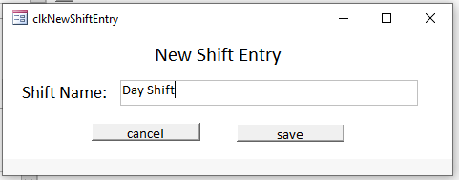

Hit ‘Save’ to update your changes to the server.
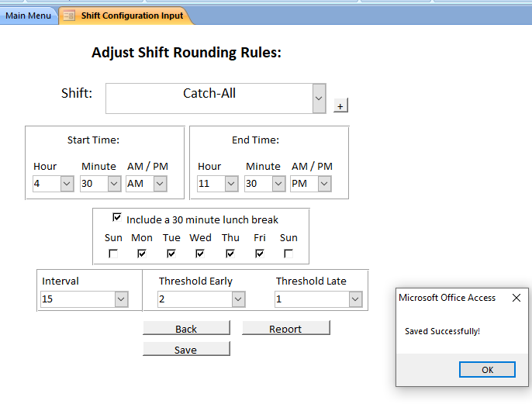

Shift Assignments:
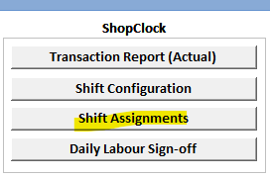
This menu simply pulls all ShopClock employees, employee #s and assigned shifts.
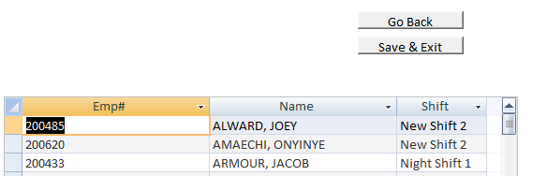
Select a row and update the dropdown to adjust an employee’s shift:
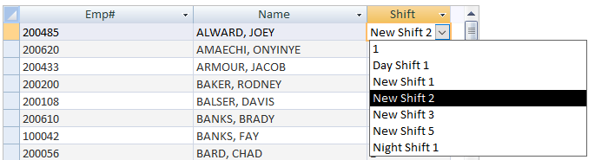
Hit ‘Save & Exit’ to push changes, ‘Go Back’ to exit without saving.
Notes:
- An employee must be created in ShopClock before they will appear in this menu.
- These shifts DO NOT effect ShopcClock shifts. These shift assignments are solely for rounding start and end times. Should an employee’s hours change drastically their corresponding ShopcClock shift may need to be adjusted as well. (i.e. original shift had auto sign-out for 4:30PM, but now employee is staying regularly until 5).
- Likewise changes to shifts in ShopcClock Admin do not effect these shift assignments
Labour sign-off:
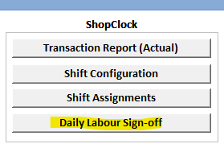
This date entry form will open:
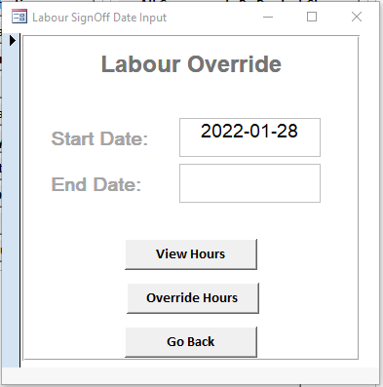
Enter a start date override hours.
Enter start and end dates to view a running sum of hours.
Labour override form: 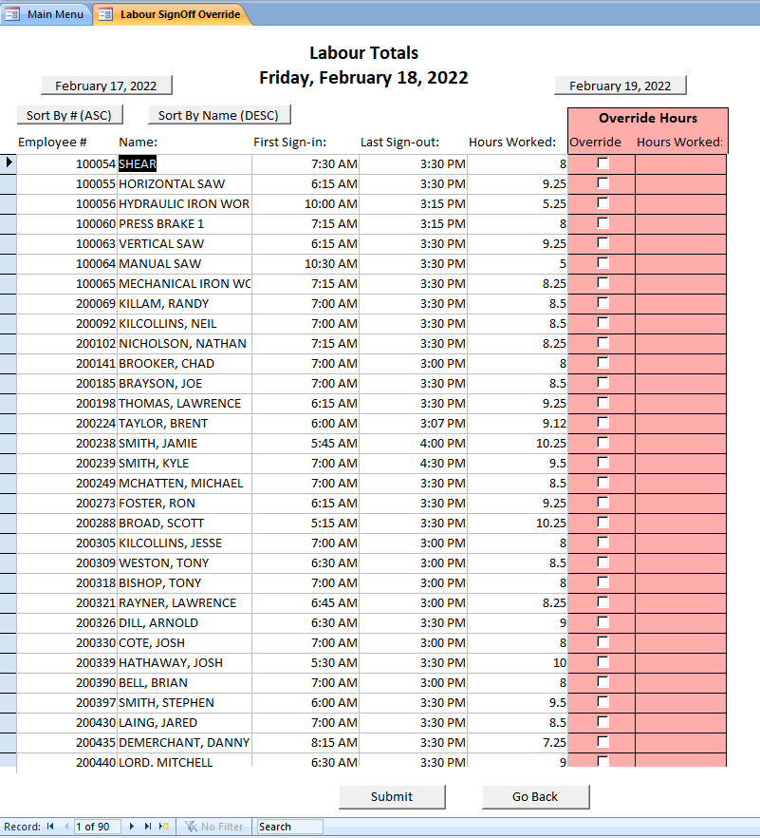

By typing a number in the ‘Hours Worked’ override field, you will set the check to True and the old value will be ignored when you save the form.
Deselect the checkbox to revert this.
After reviewing hours, hit ’Submit’ to sign off for the entered date.
Hit ‘Go Back’ to exit with saving.
Notes:
- This is form is meant to be run after the date in question. Same-day values will appear extremely inaccurate.
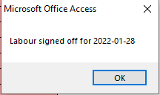
You may view a running total of hours between 2 dates given at the date input menu.
Select ‘View Hours’ to view this menu:
